MEDICINE AVAILABILITY FINDER SYSTEM
DAY 1 – PROJECT TITLE FINALIZATION
Project Title
Medicine Availability Finder System
Project Overview
The Medicine Availability Finder System helps users quickly find the availability of medicines in nearby medical stores. The system allows pharmacies to update their medicine stock and enables customers to search for required medicines without visiting multiple stores.

DAY 2 – REQUIREMENT GATHERING
Problem Statement
People often spend a significant amount of time searching for medicines across different pharmacies. In emergency situations, locating a required medicine becomes difficult and time-consuming. This system provides a centralized platform to check medicine availability in various medical stores.
Functional Requirements
- User Registration and Login
- Pharmacy Registration and Management
- Medicine Management
- Stock Management
- Medicine Search
- Availability Display
- Report Generation
Non-Functional Requirements
- Security
- Reliability
- Scalability
- Fast Search Response
- User-Friendly Interface

DAY 3 – OBJECTIVE DEFINITION
Objectives
- To help users search for medicines easily.
- To display medicine availability in pharmacies.
- To maintain medicine stock information digitally.
- To reduce the time required to locate medicines.
- To provide accurate and updated stock information.
- To improve accessibility to medicines during emergencies.

DAY 4 – USER & MODULE IDENTIFICATION
Users
Admin
- Manage pharmacies
- Manage medicines
- View system reports
Pharmacy Owner
- Add medicines
- Update stock quantity
- Manage medicine availability
Customer
- Search medicines
- View available pharmacies
- Check medicine details
Modules
1. Login Module
- User Authentication
- Secure Login for Admin and Pharmacy Owners
2. Pharmacy Management Module
- Add pharmacy details
- Update pharmacy information
- Manage pharmacy records
3. Medicine Management Module
- Add medicines
- Edit medicine details
- Delete medicines
4. Stock Management Module
- Update medicine quantity
- Track medicine availability
5. Search Medicine Module
- Search medicine by name
- Display available pharmacies
6. Report Module
- View medicine records
- Generate availability reports

DAY 5 – USE CASE DIAGRAM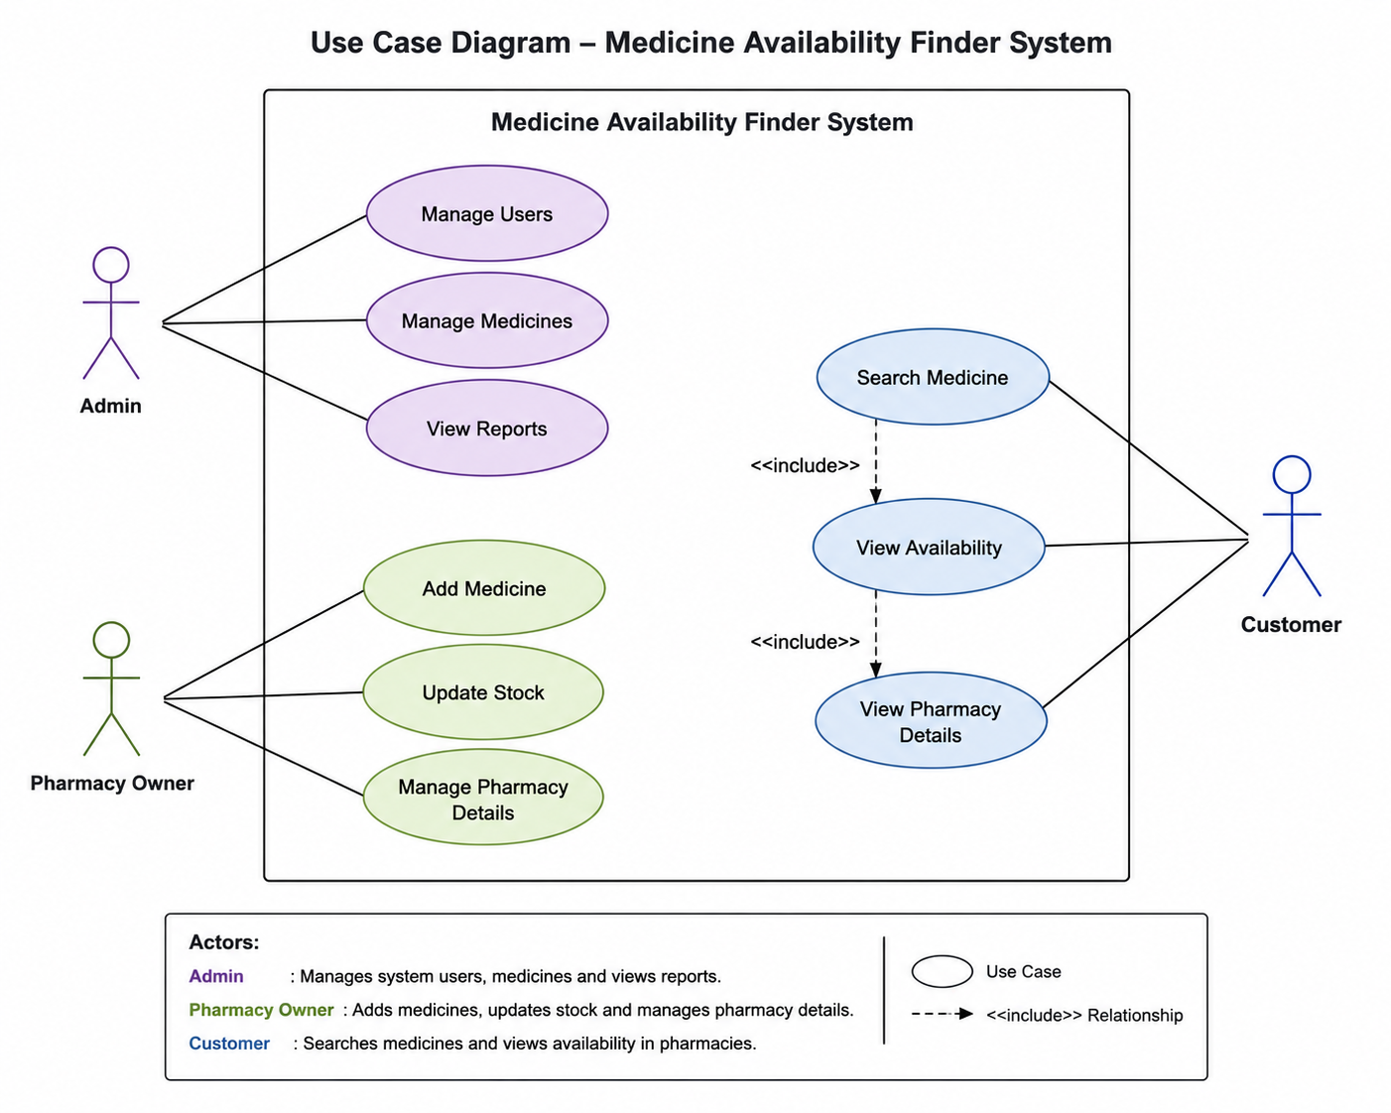

DAY 6 – DATABASE REQUIREMENT ANALYSIS
Table Name | Purpose | Primary Key | Important Fields
Users | Stores user account information | User_ID | Name, Email, Password, Phone_Number, Role
Pharmacies | Stores pharmacy details | Pharmacy_ID | Pharmacy_Name, Address, Contact_Number, Email
Medicines | Stores medicine information | Medicine_ID | Medicine_Name, Category, Manufacturer, Description
Medicine_Stock | Tracks medicine availability in pharmacies | Stock_ID | Pharmacy_ID, Medicine_ID, Quantity, Price, Last_Updated
Search_History | Stores user medicine searches | Search_ID | User_ID, Medicine_ID, Search_Date

DAY 7 – ER DIAGRAM DESIGN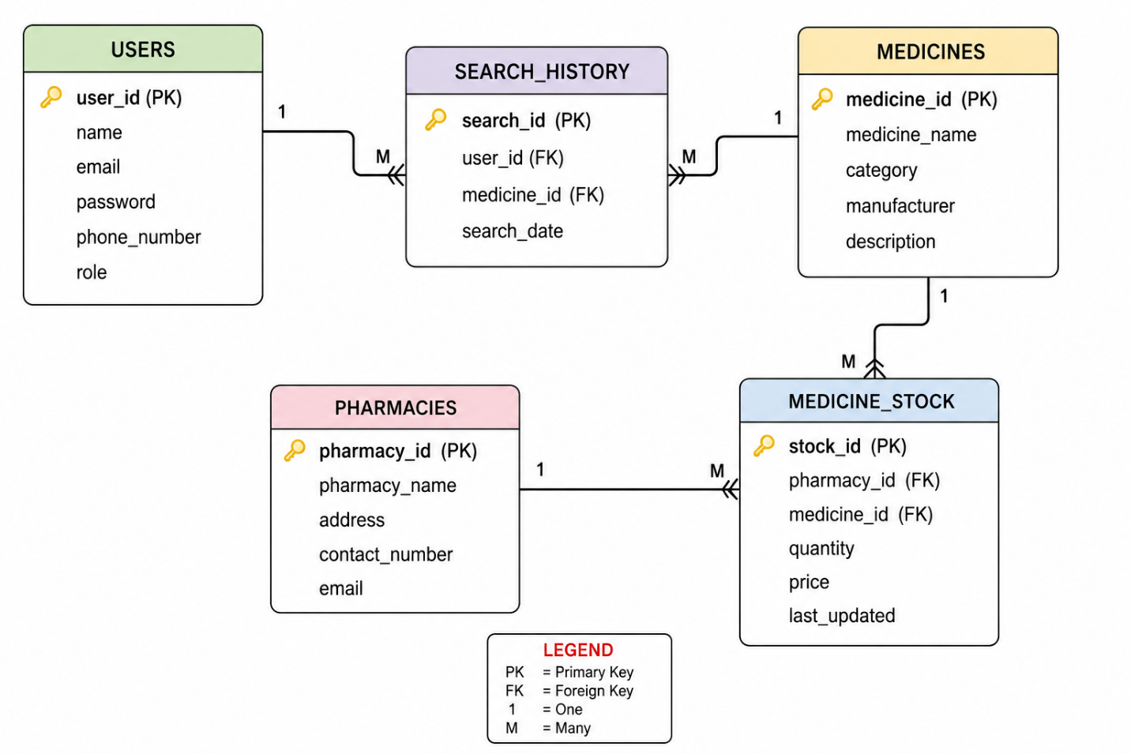

DAY 8 – DATABASE SCHEMA CREATION
SQL SCHEMA
CREATE TABLE Users (
user_id INT AUTO_INCREMENT PRIMARY KEY,
name VARCHAR(100),
email VARCHAR(100) UNIQUE,
password VARCHAR(255),
phone_number VARCHAR(15),
role VARCHAR(20)
);
CREATE TABLE Pharmacies (
pharmacy_id INT AUTO_INCREMENT PRIMARY KEY,
pharmacy_name VARCHAR(100),
address TEXT,
contact_number VARCHAR(15),
email VARCHAR(100)
);
CREATE TABLE Medicines (
medicine_id INT AUTO_INCREMENT PRIMARY KEY,
medicine_name VARCHAR(100),
category VARCHAR(100),
manufacturer VARCHAR(100),
description TEXT
);
CREATE TABLE Medicine_Stock (
stock_id INT AUTO_INCREMENT PRIMARY KEY,
pharmacy_id INT,
medicine_id INT,
quantity INT,
price DECIMAL(10,2),
last_updated TIMESTAMP DEFAULT CURRENT_TIMESTAMP,
FOREIGN KEY (pharmacy_id) REFERENCES Pharmacies(pharmacy_id),
FOREIGN KEY (medicine_id) REFERENCES Medicines(medicine_id)
);
CREATE TABLE Search_History (
search_id INT AUTO_INCREMENT PRIMARY KEY,
user_id INT,
medicine_id INT,
search_date TIMESTAMP DEFAULT CURRENT_TIMESTAMP,
FOREIGN KEY (user_id) REFERENCES Users(user_id),
FOREIGN KEY (medicine_id) REFERENCES Medicines(medicine_id)
);

TECHNOLOGY STACK
Frontend
- React.js
- HTML
- CSS
- JavaScript
Backend
- Spring Boot
- Java
Database
- MySQL
Development Tools
- VS Code / IntelliJ IDEA
- MySQL Workbench
- Postman
- Git & GitHub

